SIMATS ENGINEERING
ASSESSMENT TOOL 3 – Assignment 2

COURSE NAME: STATISTICS WITH R PROGRAMMING COURSE CODE: ITA04

COURSE OUTCOME COVERED

CO3: Construct and manipulate data frames using reshaping, merging, and file I/O operations in R to prepare structured datasets for analysis.. (BL3, BL5)

Assessment Tool Weightage: 20%

QUESTIONS: 5 Total Marks: 100

Annexure
Assignment 2

Code of Conduct:

I P.Dinesh Reddy (192425073) (Name / Reg No) certify that this submission is my original work and that I have adhered to the guidelines specified for this assessment.
I understand that any violation of academic integrity rules will result in disciplinary action.

Signature of the student: P.Dinesh reddy

Assignment 2:
- Generate 5 Questions for your Capstone Project module
- Apply the formulae and use the relevant graph to visualize it
- Upload the file in Github link
- Save the 5 Questions and Gihub link in the Excell sheet

Question 1
How does the distribution of AQI values vary across Winter, Summer, Monsoon, and Post-monsoon?
- Data type: Numerical (continuous).
- Graph: Box plot.
- Purpose: To compare the median, spread, and potential outliers of AQI across the four seasons.
Program
set.seed(123)

n <- 100

season <- rep(c("Winter", "Summer", "Monsoon",
"Post-monsoon"), each = 25)

AQI <- c(
rnorm(25, 180, 25),
rnorm(25, 240, 35),
rnorm(25, 110, 20),
rnorm(25, 200, 30)
)

AQI <- pmax(AQI, 0)

data <- data.frame(Season = season, AQI = AQI)

boxplot(AQI ~ Season, data = data,
main = "Seasonal AQI Distribution",
xlab = "Season",
ylab = "AQI",
col = c("lightblue", "salmon",
"lightgreen", "orange"))

print(aggregate(AQI ~ Season, data, summary))

Q1 <- tapply(data$AQI, data$Season, quantile, 0.25)
Q3 <- tapply(data$AQI, data$Season, quantile, 0.75)
IQR_value <- Q3 - Q1

print("First Quartile:")
print(Q1)

print("Third Quartile:")
print(Q3)

print("Interquartile Range:")
print(IQR_value)
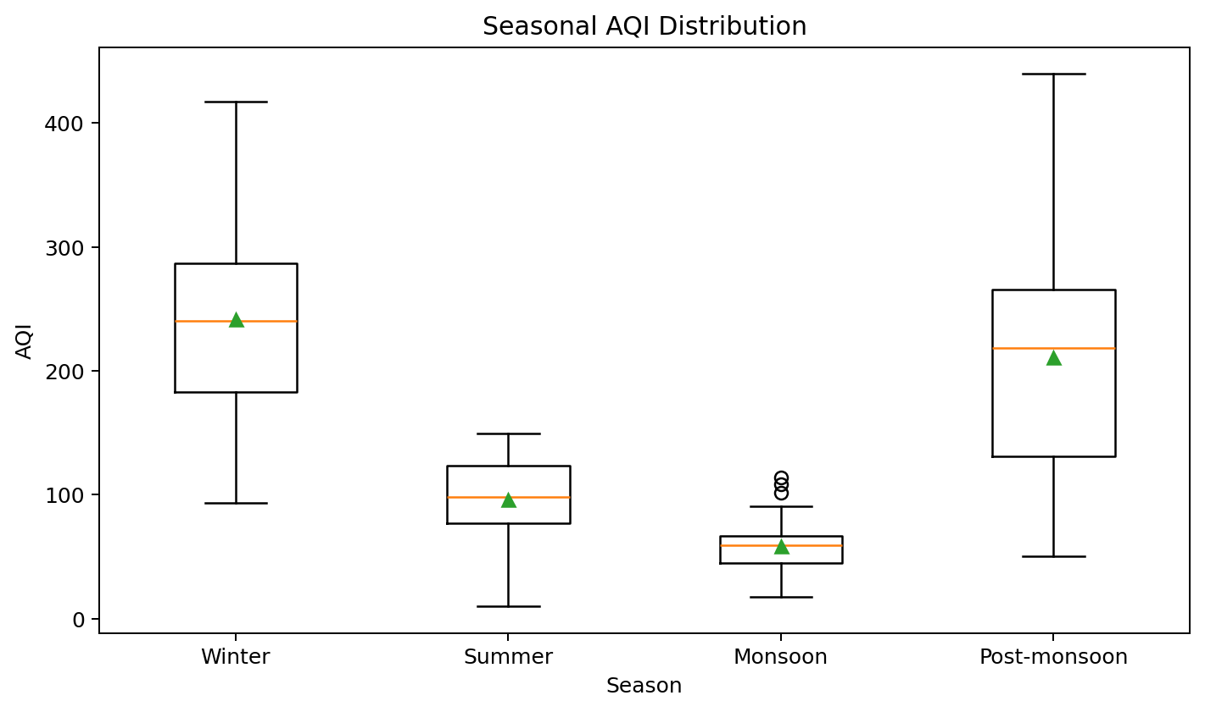
Formula
$$IQR=Q_{3}-Q_{1}$$
Question 2
Which season has the highest and lowest mean AQI values?
- Data type: Numerical AQI values grouped by season.
- Graph: Bar graph.
- Purpose: To compare the average AQI across the four seasons.

Program
set.seed(123)

season <- rep(c("Winter", "Summer", "Monsoon",
"Post-monsoon"), each = 25)

AQI <- c(
rnorm(25, 180, 25),
rnorm(25, 240, 35),
rnorm(25, 110, 20),
rnorm(25, 200, 30)
)

data <- data.frame(Season = season, AQI = pmax(AQI, 0))

mean_AQI <- aggregate(AQI ~ Season, data, mean)

barplot(mean_AQI$AQI,
names.arg = mean_AQI$Season,
main = "Average AQI by Season",
xlab = "Season",
ylab = "Mean AQI",
col = "skyblue")

print(mean_AQI)

print(mean_AQI[which.max(mean_AQI$AQI), ])print(mean_AQI[which.min(mean_AQI$AQI), ])
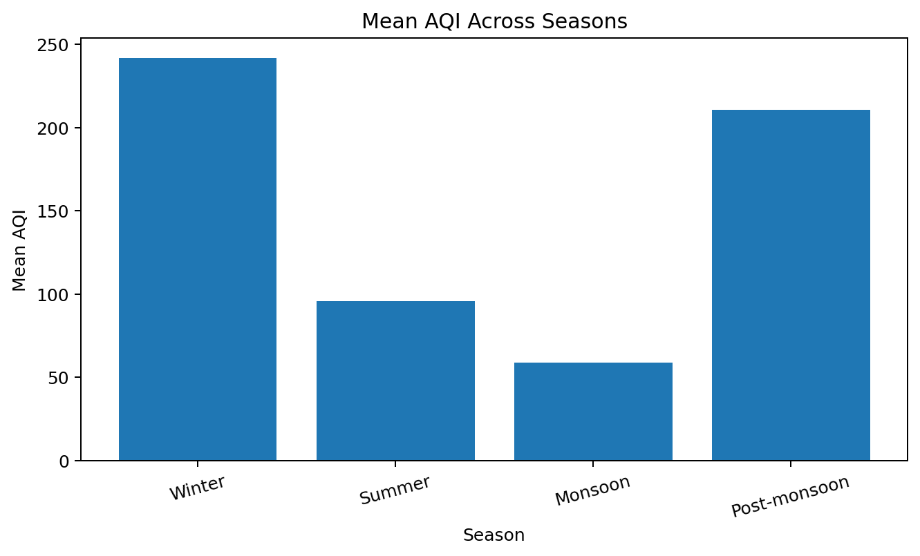
Formula
$$\overline{x}=\sum{x_{i}}/n$$

Question 3
How does the distribution and density of AQI values differ across Winter, Summer, Monsoon, and Post-monsoon?
- Data type: Continuous numerical AQI, grouped by categorical season.
- Graph type: Violin plot.
- Purpose: Shows where AQI values are concentrated and how their distributions vary between seasons.
Program
set.seed(123)

library(ggplot2)

season <- rep(c("Winter", "Summer", "Monsoon",
"Post-monsoon"), each = 100)

AQI <- c(
rnorm(100, 180, 25),
rnorm(100, 240, 35),
rnorm(100, 110, 20),
rnorm(100, 200, 30)
)

data <- data.frame(
Season = season,
AQI = pmax(AQI, 0)
)

ggplot(data, aes(x = Season, y = AQI, fill = Season)) +
geom_violin(trim = FALSE) +
labs(title = "Seasonal AQI Distribution",
x = "Season",
y = "AQI") +
theme_minimal()

print(aggregate(AQI ~ Season, data, mean))
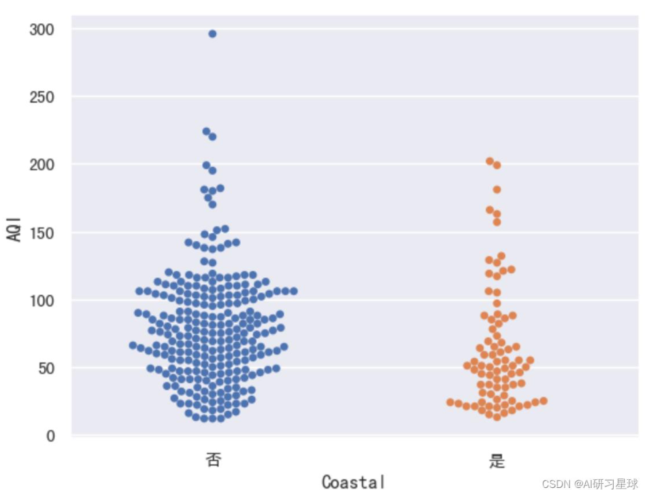
Formula
$$\hat{f}\left(x\right)=\frac{1}{nh}\sum_{i=1}^{n}{K}\left(\frac{x-x_{i}}{h}\right)$$
Question 4
How does the mean AQI change from January to December, and how reliable are the monthly mean estimates?
- Data type: Continuous numerical AQI measured over an ordered monthly period.
- Graph type: Line graph with a 95% confidence interval.
- Purpose: Identifies monthly trends while showing uncertainty around the estimated mean.
Program
set.seed(123)

months <- month.abb

monthly_means <- c(180, 190, 210, 230, 250, 220,
150, 120, 130, 170, 200, 190)

data <- data.frame()

for (i in 1:12) {
values <- rnorm(30, mean = monthly_means[i], sd = 25)

temp <- data.frame(
Month = months[i],
AQI = pmax(values, 0)
)

data <- rbind(data, temp)
}

data$Month <- factor(data$Month, levels = months)

summary_data <- aggregate(AQI ~ Month, data, function(x) {
c(Mean = mean(x),
SD = sd(x),
N = length(x))
})

summary_data <- data.frame(
Month = summary_data$Month,
Mean = summary_data$AQI[, "Mean"],
SD = summary_data$AQI[, "SD"],
N = summary_data$AQI[, "N"]
)

summary_data$SE <- summary_data$SD / sqrt(summary_data$N)
summary_data$Lower <- summary_data$Mean -
qt(0.975, summary_data$N - 1) * summary_data$SE
summary_data$Upper <- summary_data$Mean +
qt(0.975, summary_data$N - 1) * summary_data$SE

plot(1:12, summary_data$Mean,
type = "b", pch = 19,
xaxt = "n",
ylim = range(summary_data$Lower,
summary_data$Upper),
main = "Monthly Mean AQI Trend",
xlab = "Month",
ylab = "Mean AQI")

axis(1, at = 1:12, labels = months)

arrows(1:12, summary_data$Lower,
1:12, summary_data$Upper,
angle = 90, code = 3, length = 0.05)

print(summary_data)
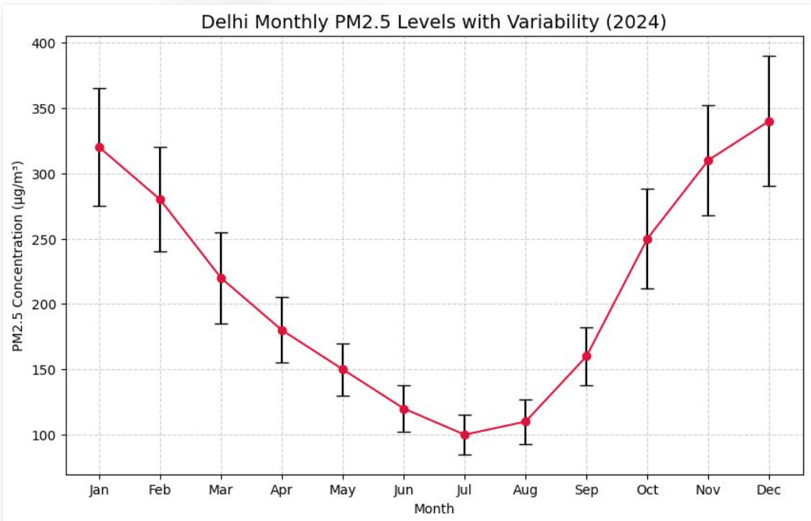
Formula
$$\boxed{\overline{x}±1.96\frac{s}{\sqrt{n}}}$$
Question 5
How do monthly mean AQI levels vary across different years?
- Data type: Numerical mean AQI values arranged by two categorical/time dimensions: year and month.
- Graph type: Heatmap.
- Purpose: Uses color intensity to reveal recurring high-AQI and low-AQI periods across years.
Program
set.seed(123)

years <- 2021:2025
months <- month.abb

data <- data.frame()

for (year in years) {
for (i in 1:12) {
base_mean <- c(180, 190, 210, 230, 250, 220,
150, 120, 130, 170, 200, 190)[i]

values <- rnorm(30, mean = base_mean +
(year - 2021) * 5, sd = 25)

temp <- data.frame(
Year = year,
Month = months[i],
AQI = pmax(values, 0)
)

data <- rbind(data, temp)
}
}

mean_data <- aggregate(AQI ~ Year + Month,
data, mean)

mean_data$Month <- factor(mean_data$Month,
levels = months)

heatmap_data <- xtabs(AQI ~ Month + Year,
data = mean_data)

heatmap(as.matrix(heatmap_data),
Rowv = NA,
Colv = NA,
scale = "none",
col = hcl.colors(20, "YlOrRd"),
margins = c(6, 6),
main = "Monthly Mean AQI Across Years")

print(mean_data)
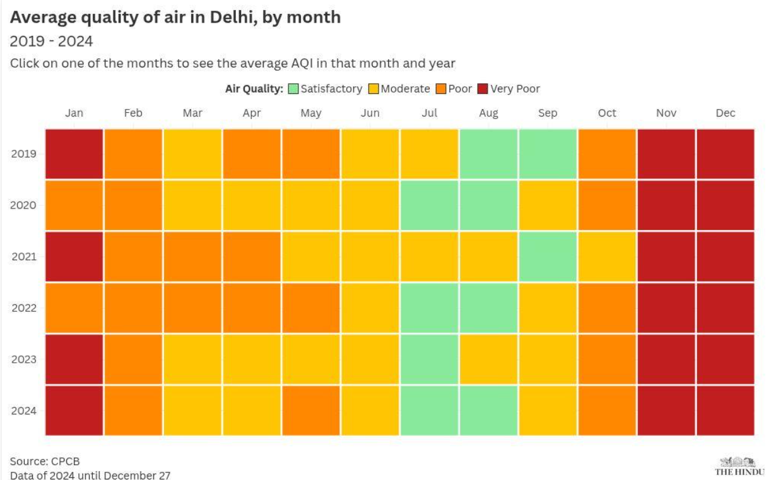
Formula
$$\boxed{{\overline{x}}_{y,m}=\frac{\sum_{i=1}^{n_{y,m}}{x_{i}}}{n_{y,m}}}$$

